IF_ERROR:
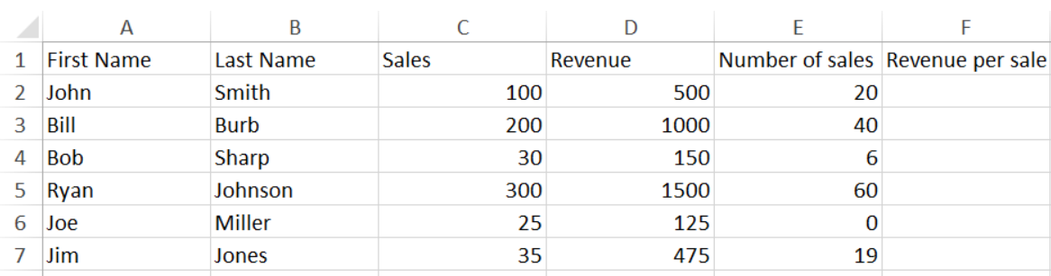

IFERROR: = IFERROR([@Revenue]/[@[Number of sales]], "No Sales yet")
